

BAHRIA UNIVERSITY (KARACHI CAMPUS)

**Project Management**

ASSIGNMENT # 1

Class: **BSE-7B**

Course Instructor: **Engr Majid Kaleem**

Submission Date: **13 Oct 2024**

Max Marks: **04**

Student Name: Muhammad Shoaib Akhter Qadri

Reg. No: 79290

**Q:** Describe the significance of the Project Integration Management knowledge area in software project management. What are the key processes and activities involved in integrating various project components, and how does it help ensure project success?

**Question 1**:

**Solution:**

Project Integration Management (PIM) software is an important area of ​​knowledge in project management that ensures that all elements of the project are executed in an orderly manner. In software development where multiple teams, tools, and processes must work together, integration is essential to align goals, trade-offs, and optimal changes PIM orchestrates synergies between project scope, schedule, cost , quality, and resources to ensure that all parties reach their intended outcomes work collaboratively to determine how the product will be delivered.

By providing a comprehensive view of the project, PIM enables better decision-making, helps manage risks, and ensures that software projects remain aligned with organizational strategic objectives It also balances stakeholder expectations with project constraints, creep, missing deadlines, or cost overruns Helps prevent— all common issues in software projects.

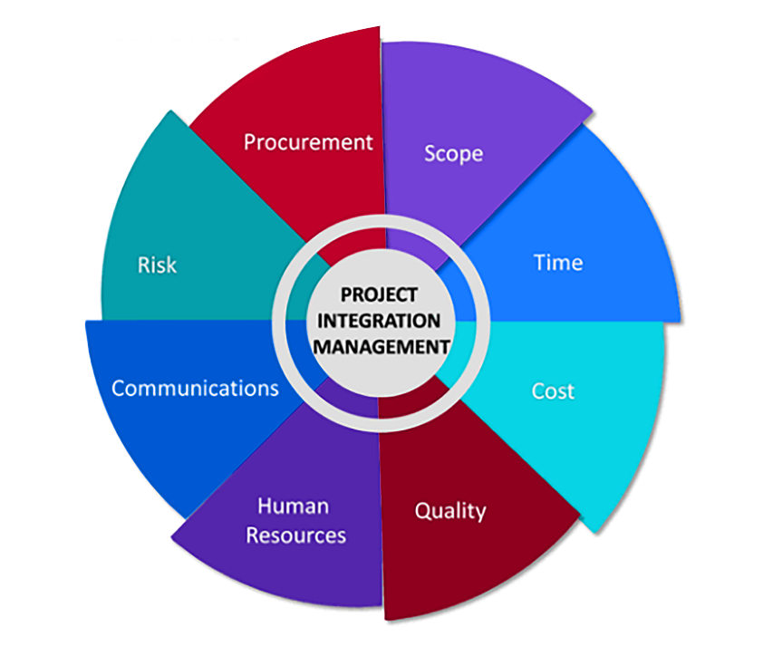

**Key features include:**

* **Developing an activity plan:** Describes the project goals, objectives and stakeholders.
* **Create a project management plan**: This provides a road map for the project, which covers everything from consequences to risk.
* **Direct and manage the project:** This is where day-to-day work is done, ensuring projects are completed on time and within budget.
* **Monitoring and controlling project work:** This involves monitoring progress, identifying problems and making adjustments as needed.
* **Perform integrated change management:** This process ensures that any changes to the project are handled smoothly with minimal disruption.
* **Close the project or category:** This is the final step, where the project is officially completed and lessons learned are documented.

**Project Integration Management ensures project success in such a way that**

* **Comprehensive Communications:**

PIM ensures that all aspects of the project, from planning to risk management, work together. In software applications, where differences between teams (e.g., developers and testers) can create challenges, PIM provides a framework for coordinating efforts, improving performance, and ensuring that business changes will move smoothly between phases (such as testing to regulation).

* **Effective change management:**

Given the dynamic nature of software development, requirements and technology are constantly changing, PIM helps monitor the impact of changes on cost, schedule, and quality Integrated change management ensures that every change request is properly evaluated , and reduces the risk of unplanned disruptions and delays.

* **Conflict with Business Objectives:**

PIM ensures that software projects align with broader organizational objectives, such as business growth, market demand, or customer satisfaction. By maintaining this alignment, the team pays less attention to technical issues at the expense of delivering business value.

* **Risk management and adaptability:**

Through ongoing analysis and knowledge management, PIM helps to quickly identify and mitigate risks. For example, if critical software modules take a long time to develop, PIM systems help to make policy changes, reallocate resources, or seek external solutions, thus reducing risk as a business will fail is reduced

* **Informed decision making:**

PIM provides a focal point for decision making, ensuring that all project decisions consider impact on the project. This is especially important in software projects where changes in one module (e.g., database configuration) can significantly impact other areas (e.g., application logic or user interface).

**Q.2** Explore the Project Scope Management knowledge area within PMI's framework. Describe how effective scope management impacts software project outcomes, and what are the primary processes involved in this knowledge area?

**Solution:**

**Project scope management in a PMI framework:**

Project scope management is an important area of ​​expertise in the Project Management Institute (PMI) program, with special emphasis in the PMBOK® Guidelines. This includes the procedures necessary to ensure that the project includes all tasks necessary for its successful completion. This domain of knowledge is important for the specification and exclusion of the project, which directly affects project outcomes.

**The importance of effective scope management:**

Effective scope management significantly impacts software project outcomes through several key mechanisms:

* **Clarity and focus:** A well-defined project approach provides clarity in goals and deliverables, and helps teams focus on important tasks. This clarity reduces misunderstandings and aligns team efforts with shared goals.
* **Risk Mitigation:** Establishing clear boundaries and maintaining space allows potential risks to be identified early. This approach enables teams to plan appropriate responses, reducing the likelihood of project failure.
* **Resource allocation:** By defining the scope of work, project managers can prioritize tasks and allocate resources more efficiently. This ensures that critical activities are completed on time and within budget, increasing overall project efficiency.
* **Stakeholder satisfaction:** Clear communication about the scope of the project helps manage stakeholder expectations, leading to greater satisfaction with the final product. When stakeholders understand what it will offer, they are less likely to be disappointed.

**Basic steps in project scope management**

The PMI framework outlines a number of important steps in project scope management:

* **Management of existing systems:** This first activity requires the development of a scope management plan that outlines how the scope will be defined, validated, and controlled over the life of the project. It serves as a reference manual for effectively handling scope.
* **Gather requirements:** In this process, project managers gather the needs and expectations of stakeholders to ensure that the project deliverables match their requirements. This step is necessary to avoid misunderstandings later in the project.
* **Define scope:** Here is a detailed description of the project and deliverables. This policy describes what is not included in the project, and provides a clear framework for implementation.
* **Create a Work Breakdown Schedule (WBS):** A WBS breaks down the scope into smaller, more manageable items or subtasks. This shared strategy helps organize team efforts and track progress more effectively.

* **Certification of scope:** This process requires stakeholders to formally accept finished products. It ensures that the outcome meets the prescribed standards and meets the expectations of the stakeholders45.
* **Resource Management:** Continuous oversight of the project is essential to effectively manage change. This process helps prevent scope creation—uncontrollable changes that can wreak havoc on timelines and budgets—by establishing a change management process

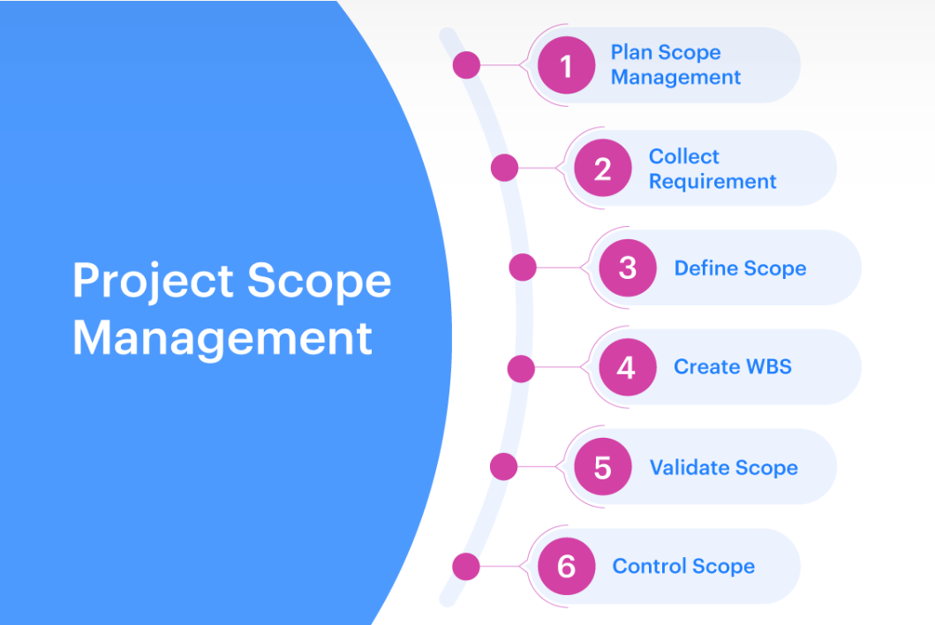

Page **1** of **1**